*LOVERS*: ABIGAIL MCGINLEY AND DELIA DETRITUS CELEBRATE QUEER LOVE & INTIMACY IN BLACK WHITE GALLERY’S UPCOMING MULTISENSORY SHOW

19th August - 31st August 2022  
422 Kingsland Road, London E8 4AA

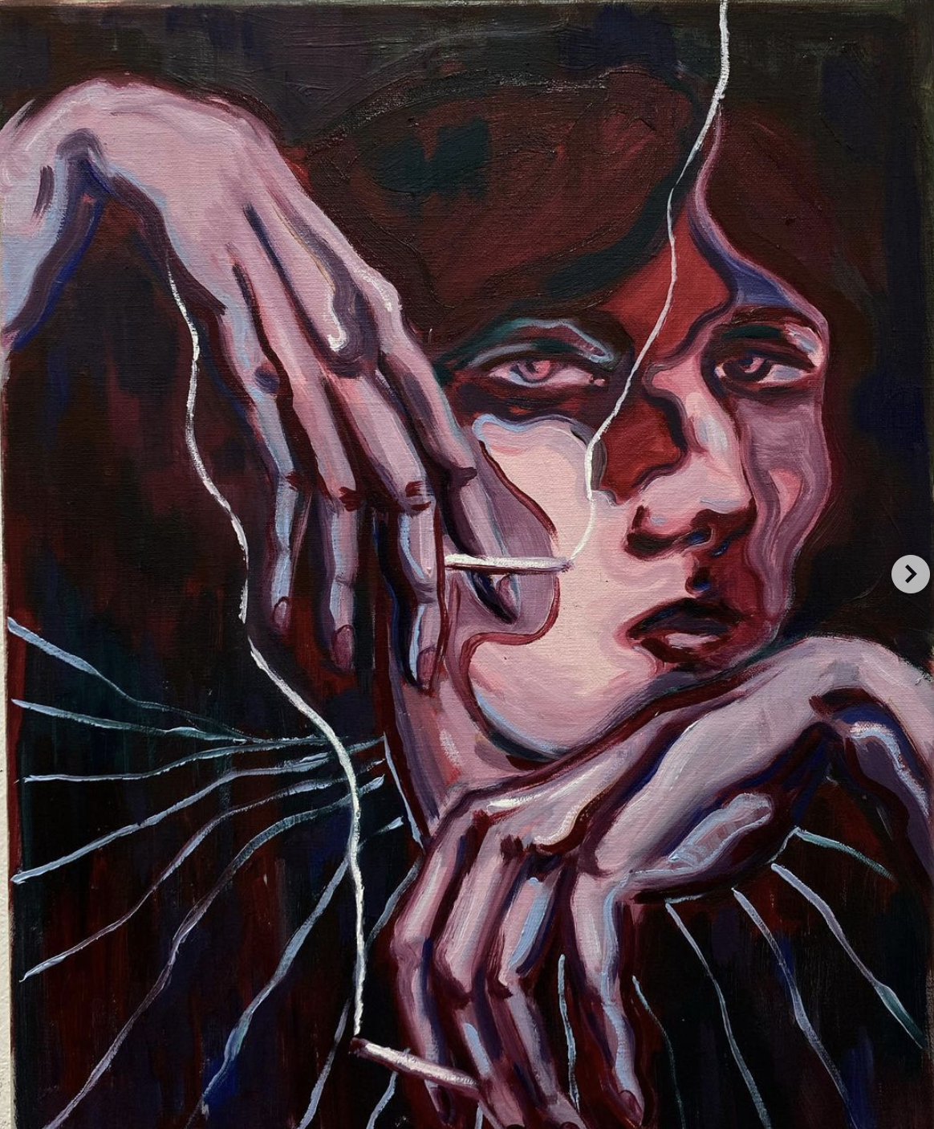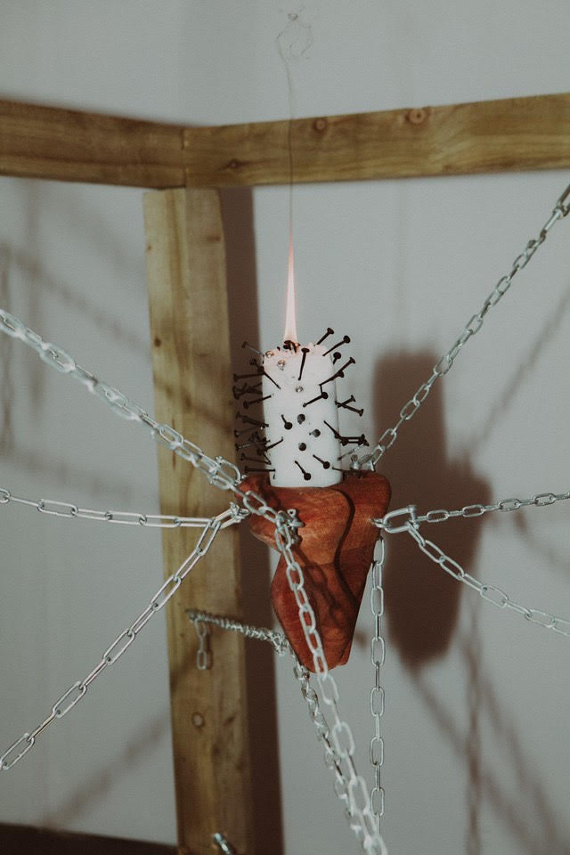  
*Double Trouble by Abigail McGinley (left), Detail of installation by Delia Detritus (right)*

Black White Gallery are pleased to present *Lovers,* an upcoming exhibition featuring painter Abigail McGinley and installation artist Delia Detritus. A love letter to intimacy, the exhibition will be the first time the couple unite creatively. Curated by Henrietta Scrine, *Lovers* will include a multisensory installation by Detritus and a new body of paintings by McGinley, dedicated to romantic intimacy between women.

McGinley, who cites Edvard Munch and Francesco Clemente as influences, states: “I will be embarking on creating a body of queer erotic paintings that are heightened and guided by the undulating textured drones of Delia’s rotating forms… I aim to use paint as a vessel to cultivate feeling and the pleasure of touch through exploring my visual language in harmony with Delia’s soundscape and undulating forms.”

While Delia states: “These are pieces about re addressing our relationship to intimacy... About dreaming of reaching down to touch yourself only to find a new body awaits you. About the many who have touched your body in ways that cause pain and about finding someone that knows exactly how to touch you, about forging a new flesh, a new touch. It’s about falling in love.”

Recently graduating from the Slade School of Fine Art, [Abigail McGinley has](https://www.instagram.com/abigaillmcg/?hl=en) already caught the attention of galleries and collectors alike. Her romantic compositions evoke joy and melancholy simultaneously. Abigail is currently partaking in the inaugural Gillian Jason Gallery Residency in Milan, alongside artists Eleanor Johnson and Milan Young.

[Delia Detritus](https://www.instagram.com/delia.detritus/?hl=en) artistic practice spans across a variety of mediums, sculpture, music, woodcarving, tattoo and writing. Self-taught, Delia’s work explores autobiographical subjects that evoke emotions such as desire and isolation. Her carving practice, where she repurposes reclaimed wood from London parks and bicycle innertubes into impact toys, explores the nature of touch, and being touched, as a trans woman. This year, Detritus co-curated *In dedication* with The Koppel Project and We Exist. She was also one of the contributing artists in the show.

VISITOR INFORMATION:

Black White Gallery advocates a contemporary approach that challenges the traditional institutionalised art market. Established in 2022 by Charles Leffler and Henrietta Scrine, Black White Gallery champions contemporary visual art, captivating ways of exhibiting and strives to build genuine relationships with both emerging and established artists, providing a safe space that promotes constructive and empowering dialogue.

Exhibition runs: 19th - 31st August 2022

Private view: 6pm - 9pm 18th August 2022

Address: 422 Kingsland Road, London E8 4AA

Opening times: Tuesday - Saturday 11am - 7pm, Sunday 11am - 4pm

[www.blackwhitegallery.co.uk](https://www.blackwhitegallery.co.uk/)

[@blackwhitegallery__](https://www.instagram.com/blackwhitegallery__/)

Press enquiries: [henrietta@blackwhitegallery.co.uk](mailto:henrietta@blackwhitegallery.co.uk)